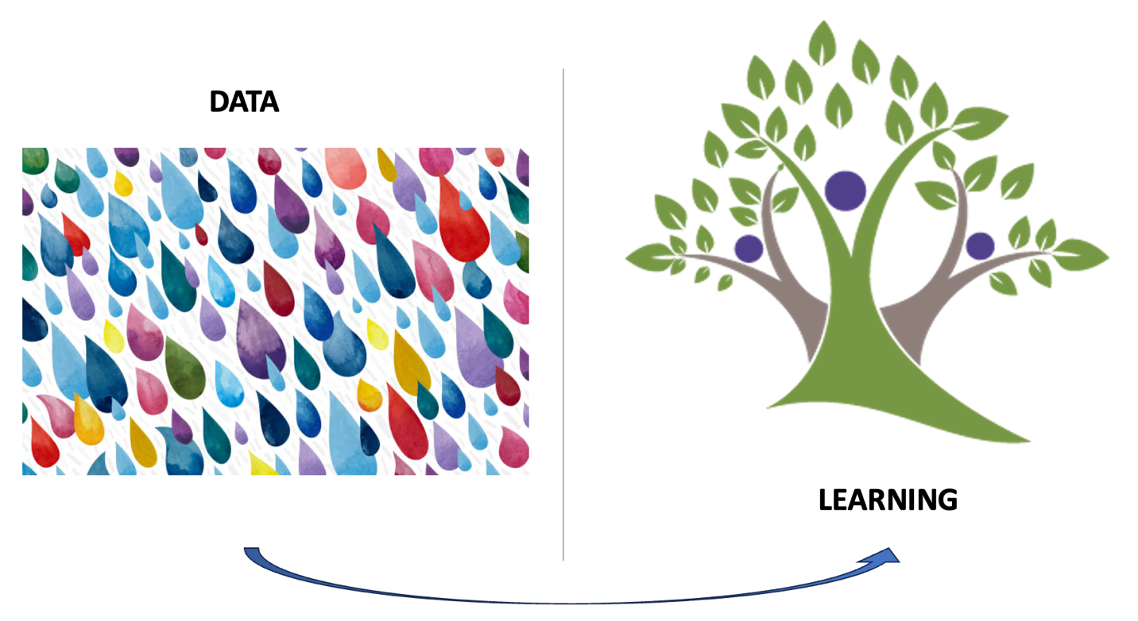

Quantitative Data Analysis . . . Quantities - counts and measures . . . Computational Accuracy
Qualitative Data Interpretation . . . Qualities - entity relationships . . . Truthful Communications

I have had a long and successful career in Quantitative Data Analysis, specifically time-series data analysis to model changes in time-sensitive values of facts. I founded Information Advantage to incorporate advanced analytic tools in reports, reports generated based on intelligent agents used to detect significant changes. Information Advantage attracted Venture Capital shortly after securing Target as a major customer; then grew to over 600 employees in eight years. Rather than seeking a patent, I wrote a book. Securing Information Advantage as an early market leader in what the Gartner Group described as ‘Business Intelligence technology’ . Today, the Business Intelligence Market is a $30 billion market dominated by Microsoft, Oracle and IBM. Information Advantage was acquired following its’ IPO. and its’ technology traveled through multiple acquisitions and now resides somewhere inside Broadcom.
Several years ago, I took an interest in NLP technology, seeing it as a solution to closing the growing gap between quantitative and qualitative data management, that some refer to as ‘structure data’ and ‘unstructured data’. AI leapfrogged NLP! I refocusedc on AI as a tool to advance Human Learning and Human Intelligence. i concluded AI is a oworedful tool to support Qualitative Data Interpretation; interpretating what people are communicating to better support human learning.
I began to focus on the learning challenges of individuals and s saw an opportunity to disrupt Patient Education. There is a generally accepted belief that Patient Education is essential to improve medical care outcomes and reduce cost; however, Patient Education is failing to meet those goals. Publishing and distributed more pamphlets only serves to drive people to Google for advice. The problem: ‘Google is not licensed to practice medicine’ and ‘Google is not concerned about malpractice’.
We need to create a more efficient approach to supporting Critical Learning. I believe this is possible by employing AI to develop Learning Tools to support Visual, Interactive and Adaptive Learning. VIA Learning using AI to personalize learning.
While a goal of improving Learning is not limited to ‘Patient Education’ it is a good place to start. I took it one step further to prototype a tools for Dementia Learning.

